Project Design Phase
Solution Architecture
Date | 15 February 2025
Team ID | [Enter Team ID]
Project Name | ShopEZ - Full Stack MERN E-Commerce Platform
Maximum Marks | 4 Marks

Solution Architecture:
Solution architecture for ShopEZ describes how the frontend, backend, authentication, database, and admin modules work together to solve the online shopping problem. The system follows a three-tier MERN architecture with React.js for the presentation layer, Node.js and Express.js for application logic, and MongoDB for data storage.
• Find the best technical solution for product browsing, cart management, checkout, order placement, and admin product management.
• Describe the system structure, behaviour, data flow, and security controls for project stakeholders.
• Define the main features, implementation layers, and delivery specifications of the ShopEZ web application.
• Provide a clear architecture that can be developed locally and later deployed to cloud platforms such as Vercel, Render, and MongoDB Atlas.
ShopEZ Solution Architecture Diagram:
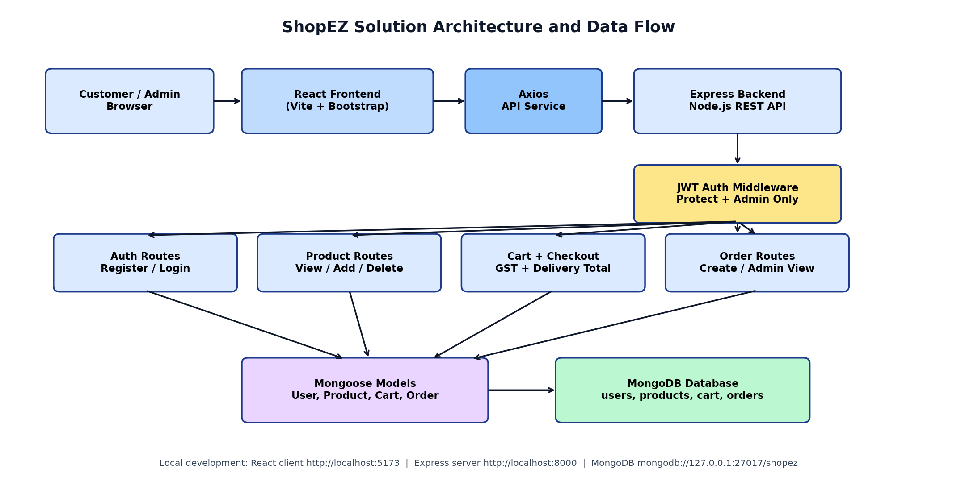
Figure 1: ShopEZ MERN architecture and data flow
Architecture Layers:
Layer | Description
Presentation Layer | React.js frontend built with Vite. It contains pages and components such as Home, Products, Product Details, Cart, Checkout, Orders, Profile, Navbar, and Admin Dashboard.
API Communication Layer | Axios is used from the React frontend to communicate with Express REST API endpoints such as /api/auth, /api/products, /api/cart, and /api/orders.
Application Layer | Node.js and Express.js handle server logic, routing, controllers, middleware, validation, error handling, and protected admin/user operations.
Security Layer | JWT-based authentication protects cart, checkout, profile, orders, and admin routes. Admin-only middleware restricts product management and all-order viewing.
Data Layer | MongoDB stores users, products, cart items, and orders. Mongoose schemas and models are used for data structure and database interaction.

Main Components and Technologies:
Component | Description | Technology
User Interface | Customer and admin interact with ShopEZ through a responsive web UI. | React.js, Bootstrap, CSS
Frontend Routing | Navigation between Home, Products, Product Details, Cart, Checkout, Orders, Profile, and Admin pages. | React Router DOM
API Integration | Frontend sends HTTP requests to backend APIs and receives JSON responses. | Axios
Backend API | Server exposes authentication, product, cart, order, and admin endpoints. | Node.js, Express.js
Authentication | Login generates JWT token; protected routes require Bearer token. | JWT, bcrypt.js
Database | Stores users, products, cart items, and orders in separate collections. | MongoDB, Mongoose
Admin Module | Admin can access dashboard and manage products/orders using role-based authorization. | Express middleware, JWT role check
Local Infrastructure | Frontend, backend, and database run locally during development. | localhost:5173, localhost:8000, MongoDB localhost:27017

Data Flow Explanation:
Step | Flow Description
1 | User opens ShopEZ frontend in browser.
2 | User registers or logs in using email and password. Backend verifies credentials and returns JWT token.
3 | User views products. React frontend calls the product API and displays product cards and product details.
4 | User adds products to cart. Cart operations are protected and associated with the logged-in user.
5 | User proceeds to checkout. The system collects delivery details and calculates subtotal, GST, delivery charge, and grand total.
6 | Order is placed and stored in MongoDB. User can view order history.
7 | Admin logs in with admin role and accesses dashboard to manage products and view orders.

Architecture Benefits:
• Separation of frontend and backend improves maintainability and makes development easier.
• REST API design allows the frontend and backend to communicate clearly using JSON.
• JWT authentication improves security by protecting cart, checkout, profile, and admin pages.
• MongoDB collections make the application flexible and suitable for e-commerce data.
• The architecture can be scaled later by deploying frontend, backend, and database separately on cloud platforms.
Deployment View:
Deployment Type | Description
Current Development Setup | React frontend runs on localhost:5173, Express backend runs on localhost:8000, and MongoDB runs locally using MongoDB Compass.
Future Cloud Deployment | Frontend can be deployed on Vercel or Netlify, backend on Render or Railway, and database on MongoDB Atlas.

Reference:
Architecture concepts adapted from the template reference: https://aws.amazon.com/blogs/industries/voice-applications-in-clinical-research-powered-by-ai-on-aws-part-1-architecture-and-design-considerations/

